AI FitTrack
Ideation Phase
Brainstorm & Idea Prioritization
Date | 26-09-2026
Team ID | SWTID-2026-6939
Project Name | AI FitTrack API
Maximum Marks | 4 Marks

Brainstorm & Idea Prioritization Template:

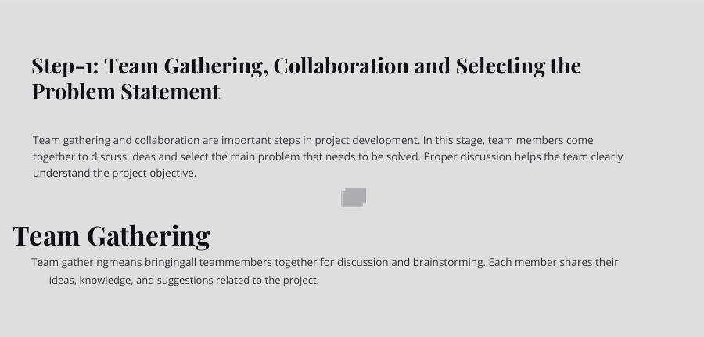

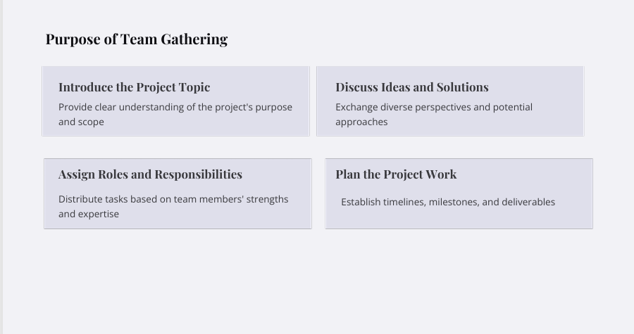

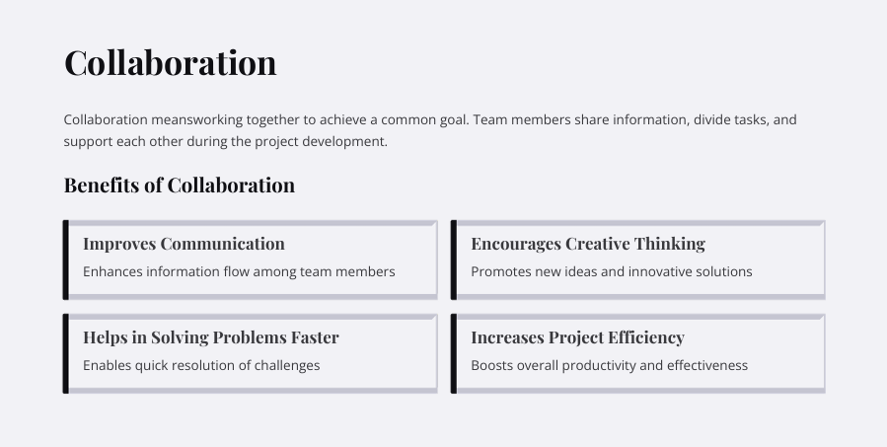

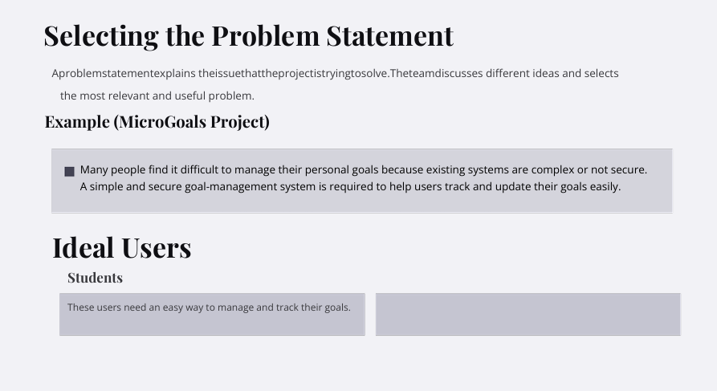

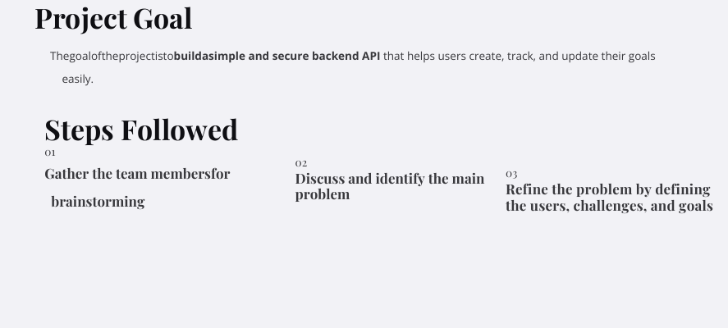

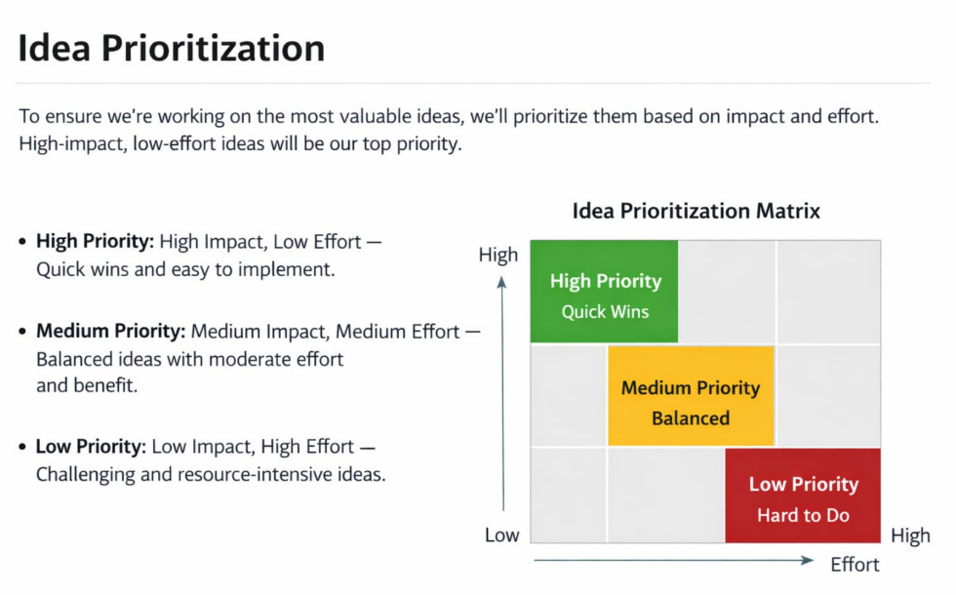

AI FitTrack – Brainstorm & Idea Prioritization
1. Problem Identification
Users who exercise regularly may find it difficult to maintain a centralized workout history, search previous workouts, monitor progress, and decide which exercises suit their fitness level. Manual tracking can also make workout history and performance calculations time-consuming.
2. Brainstormed Ideas
• Secure user registration and login using JWT authentication
• Centralized workout record management
• Add, view, update and delete workout records
• Search workouts by workout name, category or date
• AI-powered personalized workout recommendations
• AI-generated fitness insights from workout statistics
• Secure password storage using bcrypt.js
• Modular MVC-based backend architecture
• Future nutrition tracking, BMI calculation, wearable integration and workout reminders
3. Idea Prioritization
High Priority:
• Secure authentication and protected APIs
• Workout CRUD management
• Workout search
• AI workout recommendations
• AI fitness insights

Medium Priority:
• Centralized error handling and validation
• Modular service-layer design
• API testing through Postman

Future/Extension Ideas:
• Nutrition tracking
• BMI calculation
• Wearable device integration
• Workout reminders
• Fitness analytics dashboard
4. Selected Project Idea
AI FitTrack was selected as the project idea. It provides a centralized and secure backend for workout tracking and uses Google Gemini AI to generate personalized workout recommendations and fitness insights based on user information and workout statistics.
5. Expected Outcome
The proposed system aims to reduce manual workout record keeping, protect personal workout data, make workout history easier to manage and search, and provide AI-assisted guidance. The selected architecture also supports future expansion.

